1. Provide a screenshot of your Docker desktop to show that the MySQL Docker *container* that you created for Activity 14.3 is still running.

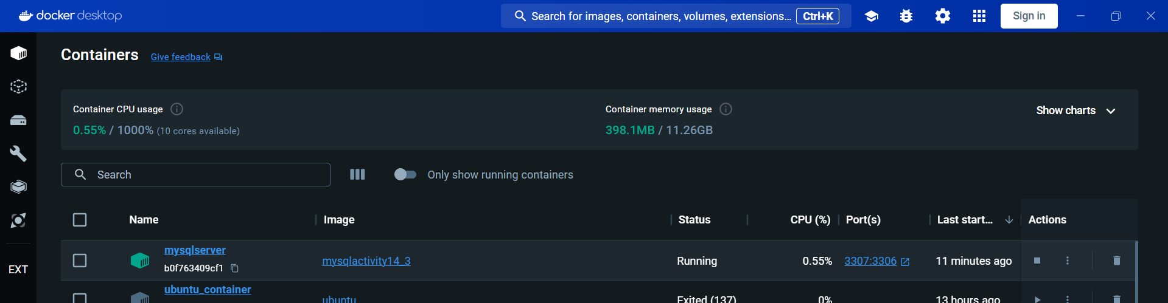

1. Provide a screenshot of the output from this command to show that the myCDCNetwork Docker network is available.

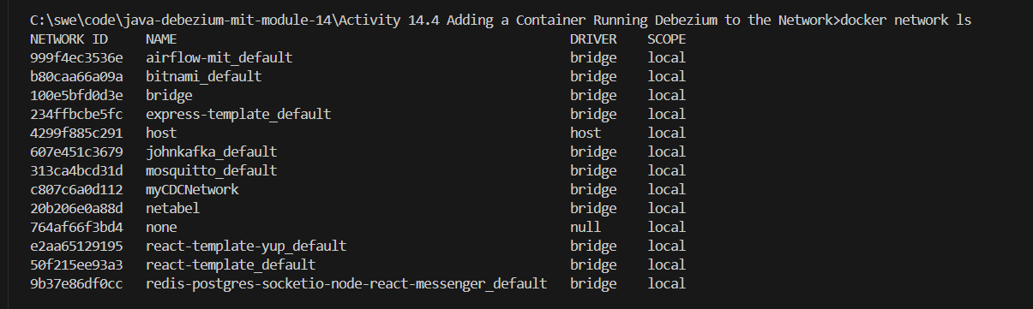

1. Provide a screenshot to show that you successfully unzipped the debeziumActivity14_4.zip file and created the debeziumActivity14_4 folder.

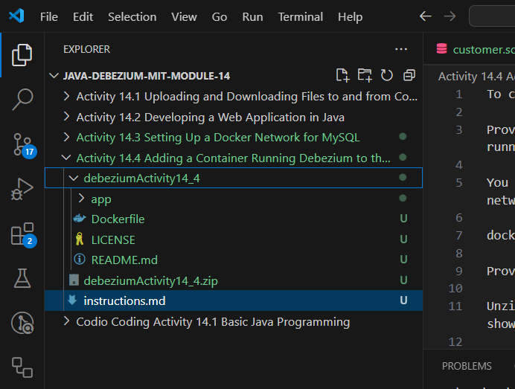

1. Provide a screenshot showing that you successfully ran the docker build command to create a Debezium Docker *image*.

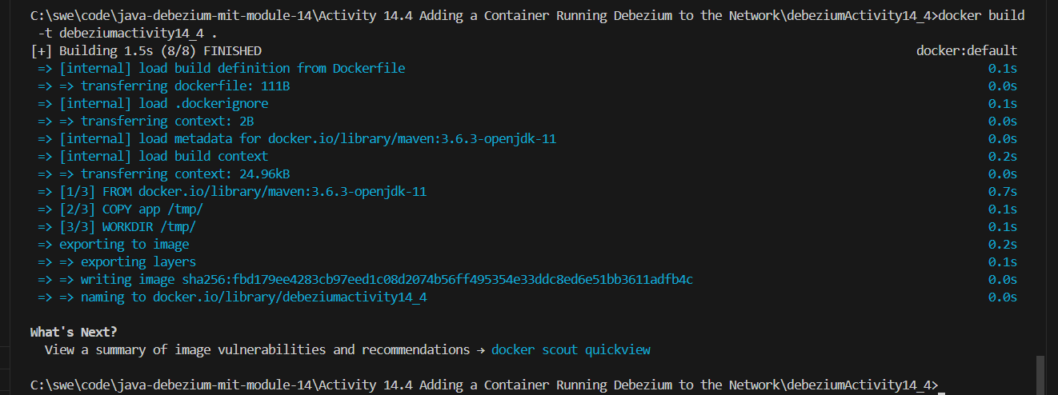

1. Provide a screenshot to show that you successfully ran the command to create the Debezium *container*.



1. Provide a screenshot of the Docker desktop showing the two *containers* running.

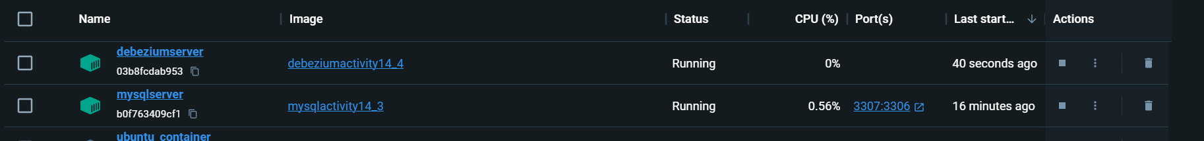

1. Provide a screenshot of the console application running to show that Debezium detected the new row that was created for the customer table.

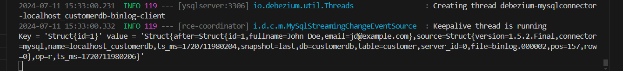

1. Provide a screenshot of Workbench to show that you successfully ran the INSERT *query* to create a new row in the customer table.

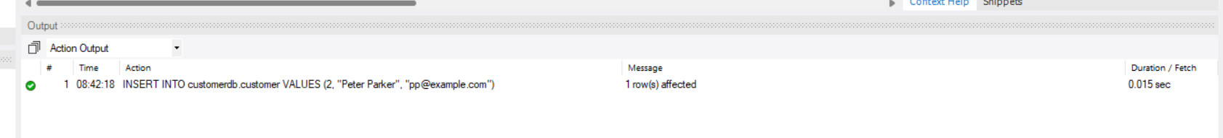

1. Provide a screenshot of the console application running Debezium to show that Debezium detected the new row that was created in the customer table from Workbench.

